**LAB 2**

**AIM: Implement basic intensity transformation functions: -**

* **Image Negatives**
* **Log Transformations**
* **Power-Law (Gamma) Transformations**
* **Contrast Stretching (Piecewise Linear transformation)**

**1. Take your own grayscale photo and apply negative transformation.**

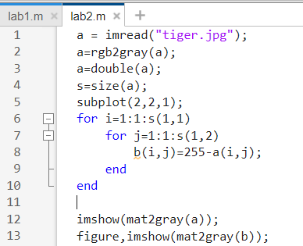

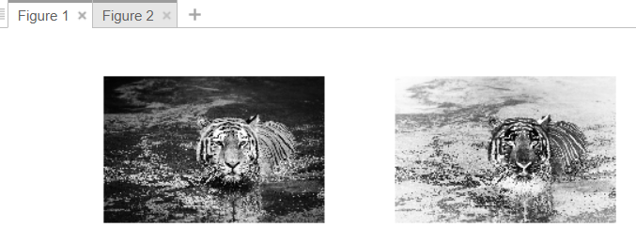

**2. Consider image ex_log.tif. Enhance the image by applying log transformation.**

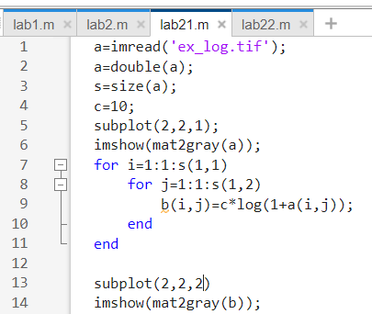

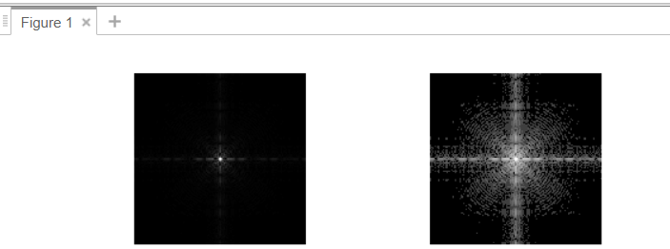

**3. Consider images ex_power1.tif and ex_power2.tif and enhance them with power**

**law transformation.**

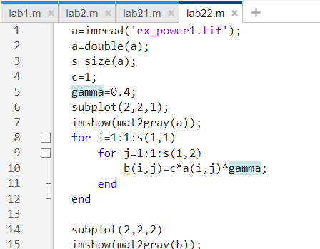

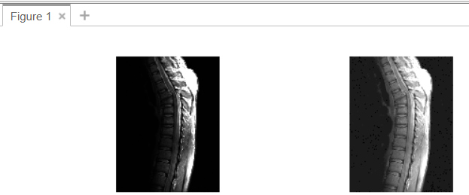

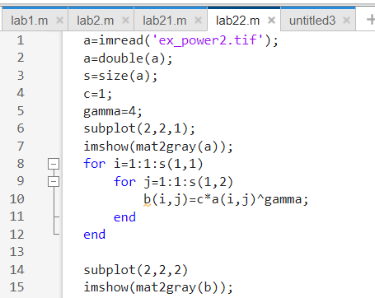

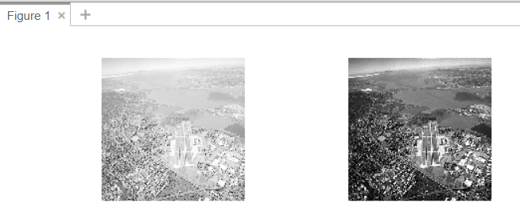

**4. Consider your over exposed photo (that you generated for assignment 1) and**

**enhance it by power law transformation. Specify the value of gamma which is**

**suitable for this enhancement.**

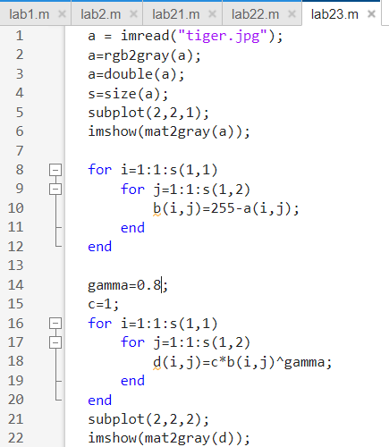

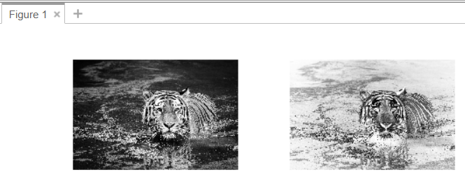

**5. Consider your under exposed photo (that you generated for assignment 1) and**

**enhance it by power law transformation. Specify the value of gamma which is**

**suitable for this enhancement.**

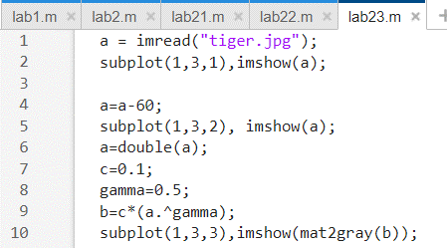

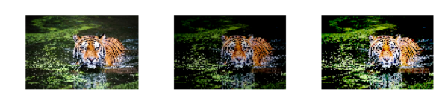

**6. Contrast Stretching (Example) : A 3 x 3 8 bits/pixel image is given by**

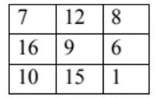

**Apply contrast stretch to the image so that the new image has a dynamic range**

**of [0, 255]. Also show the output image. Sketch the transformation you used for**

**contrast stretching.**

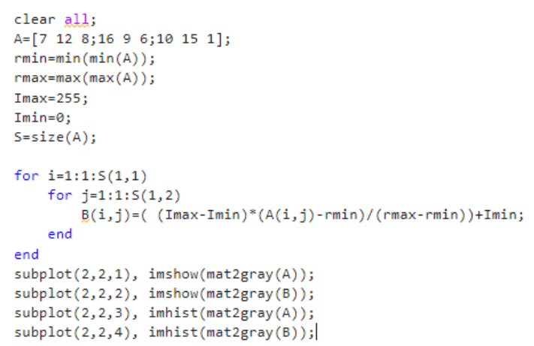

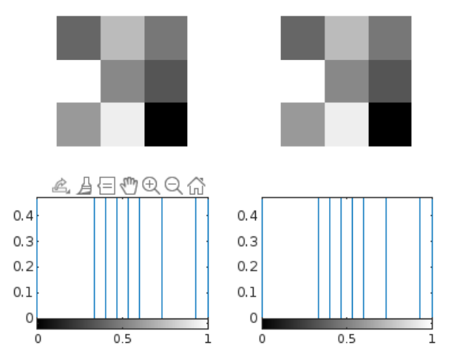

**7. Do contrast stretching for the image ex_contrast.tif. Obtain contrast stretched**

**image from low contrast image and apply thresholding.**

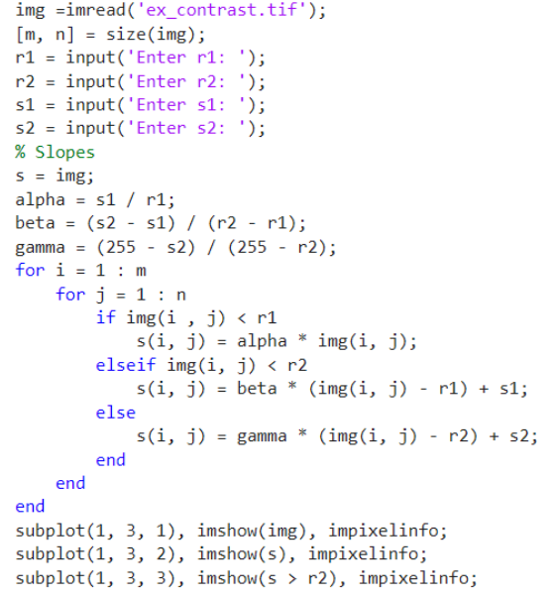

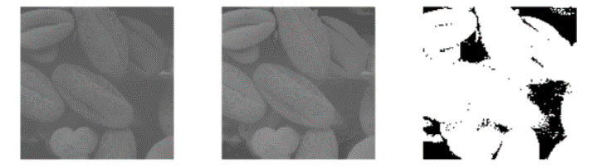

**8. Take any photo of yours –**

**a. convert it to gray scale,**

**b. create a function that would decrease the contrast of this image.**

**c. enhance the contrast of that image using piecewise linear operation for**

**contrast stretching.**

